How to “Job Cost” in QBO Plus
- Set up products and services for the work you are going to do
  - Two sided items, just like in QBDT
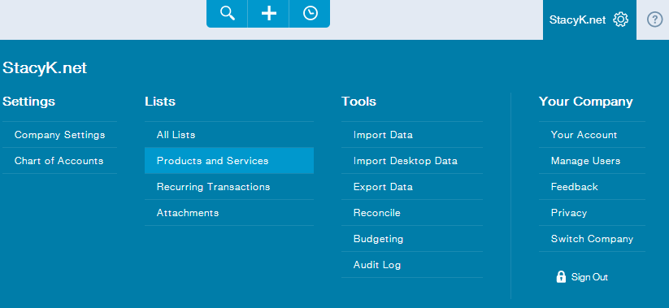
  - Drill into the products & services you will be using to track the work for the job (items) and make sure they are two sided linked to the appropriate COGS/Expense and Revenue account:
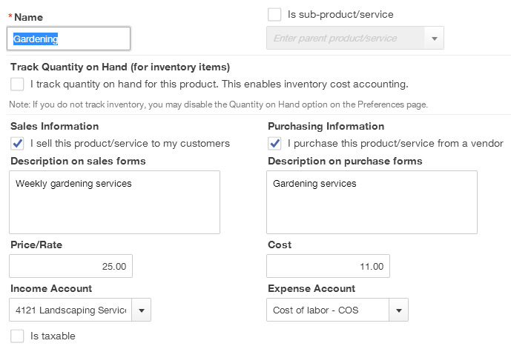
- Add Customer and the “Job” as a Sub-Customer
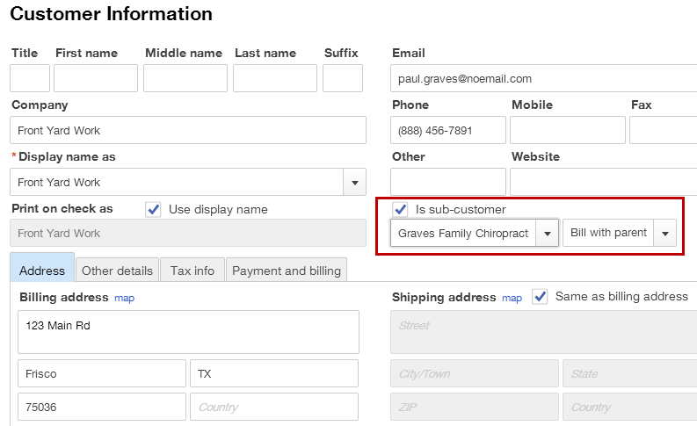
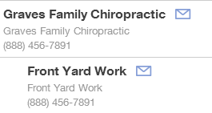
- Key Company Settings to Consider and Turn On
  - There are company settings to set for the Estimate first, like calling the “estimate” something else. You can do this from Gear icon, Settings, Company Settings, Sales, Customize:
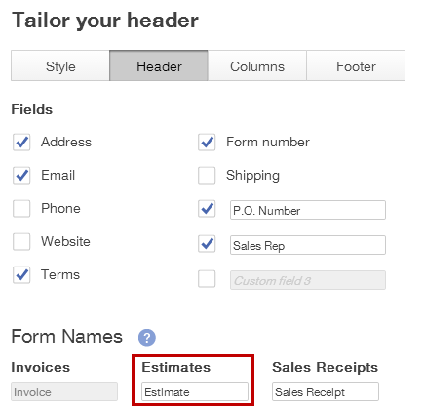
  - You might turn Deposit and Service Date on too in Company Settings:
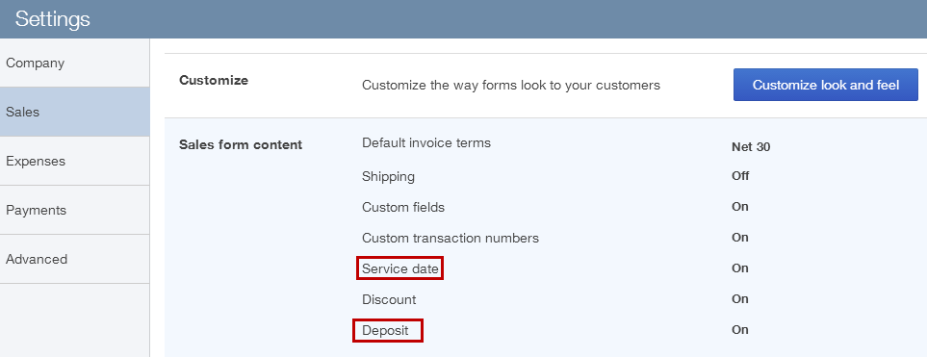
  - Some “advanced” settings to consider as well:
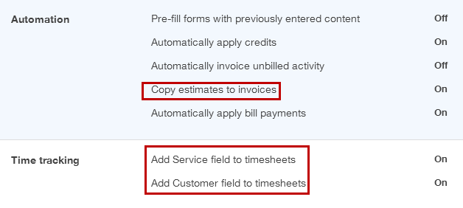
- Create the Estimate

Even though QBO does not support Estimate v Actual reporting, we start tracking the job using an estimate, add your products and services to the estimate, so you can copy to invoice when ready. QBO does not support progress invoicing either, but I have included a link to Stacy Kildal’s workaround, and an estimate is required to start.
  - Open a new Estimate form, choose the customer job (sub-job) and enter your items (products and services) that represent the work you will be doing. Enter the hours/QTY as well and any appropriate description.
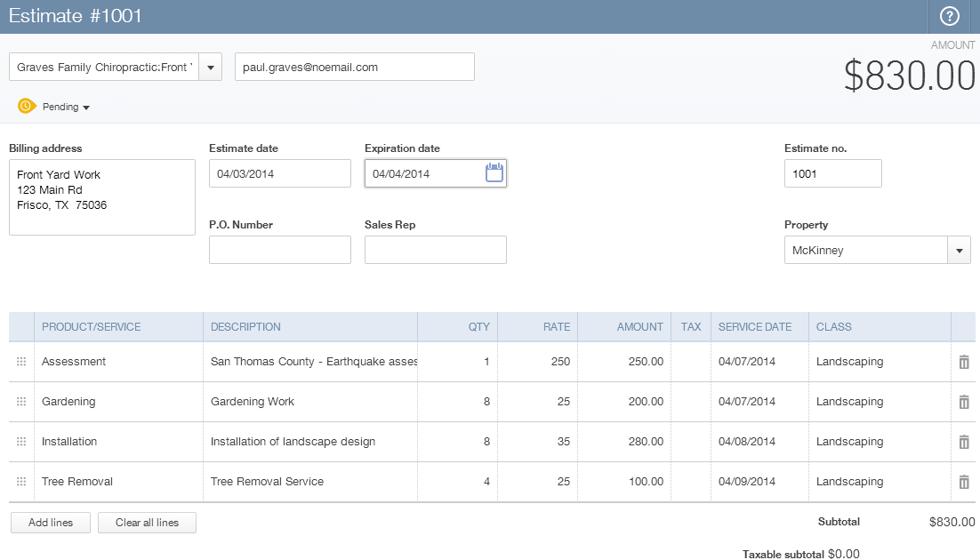
  - Note you can track open estimates from the Customers tab:
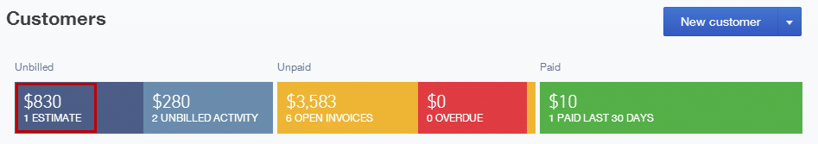
- Connecting costs to the job, running Profit and Loss by Job report
  - As you start to enter costs to the jobs, whether you are using a check, bill, credit card or some other expense type transaction, make sure you select the sub-job in the Customer field. And use the Items tab:
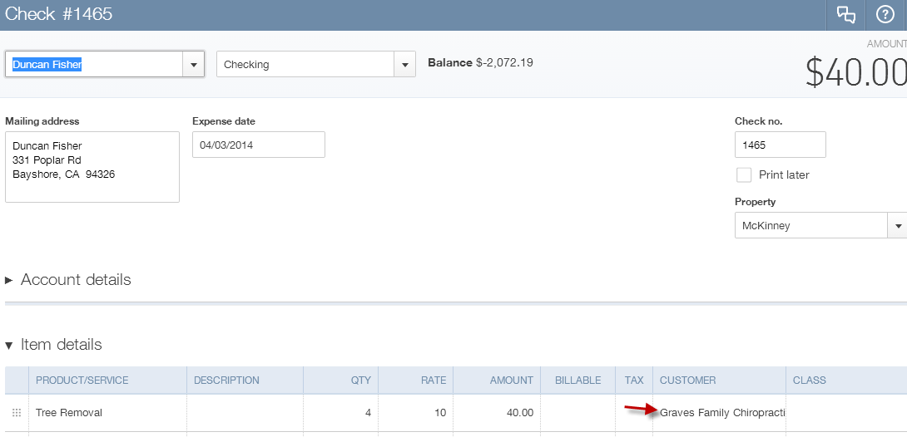
  - This way, the cost will be connected to the appropriate job on the Profit and Loss report, filtered by the sub-job:
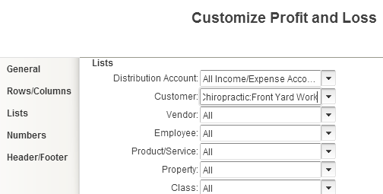

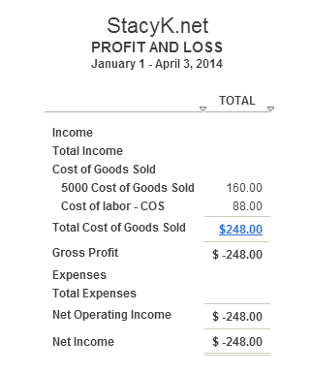
Currently, there is no way to connect a paycheck to the job…
- Invoice in full for the job against the Estimate
  - Now let’s create an invoice for the entire estimate once the job is done and then look again at the P&L, filtered for the job:
  - From the Customers list, click Estimate which is the first tab in the Customer progress bar, then Start Invoice tab:
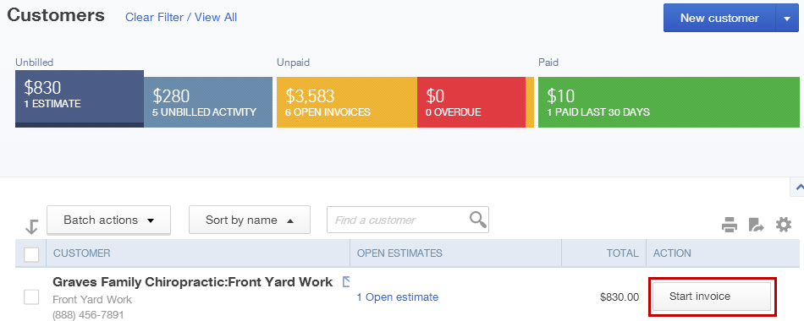

  - Invoice template will open, and you will see the Estimate to Add in the Drawer on the right:
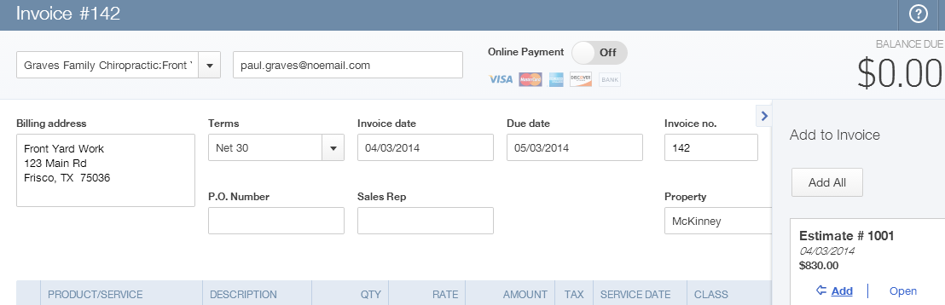
  - Items are added to the invoice:
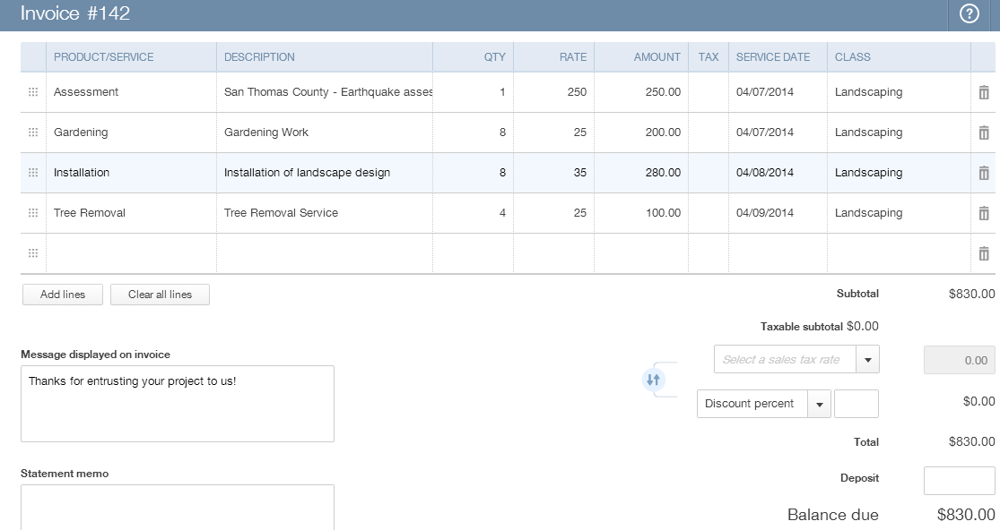

  - Now let’s check out the P&L filtered for the job:
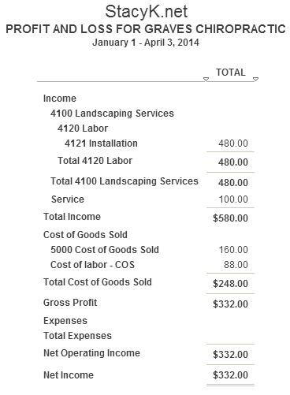
Note: QBO Plus also allows you to pass time, expense and items thru to invoice too, just assign the customer to the cost transaction and make sure the Billable box is checked, just like in QBDT…

